Archbishop Lori Statement on Kabul Airport Attack, Pray for Peace
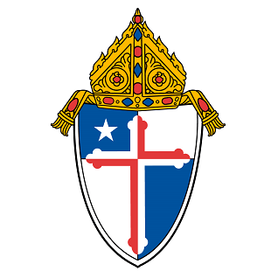ARCHDIOCESE OF BALTIMORE
AUGUST 26, 2021
PRESS RELEASE
Aug. 26, 2021
BALTIMORE, MD — The following is a statement from Archbishop William E. Lori:
“I am heartbroken by the increasingly violent events occurring in Afghanistan and the senseless loss of precious life. The terrorist attack on the airport in Kabul is the latest act of violence that targeted innocent lives and the U.S. and international forces who are struggling to safely evacuate American citizens, government contractors, translators and other Afghan allies and refugees. Acts of terror are an attack against all of us and have no place in a civilized or just society. Please, I urge the members of our Archdiocese of Baltimore to join Our Holy Father, Pope Francis and our global community to pray for peace and an open dialogue that creates a path to solutions and not to more death and suffering. We also pray for the 13 members of the U.S. military who lost their lives in this attack and for the safety of those service members who remain in Afghanistan. Please also remember all of the victims, their families and loved ones.

